MCKV INSTITUTE OF ENGINEERING

Computer Science and Engineering – Data Science

***Name - Abhinaba Sarkar***

***Roll No. - BTECH/CSE-DS/2020/47***

**Assignment Number: *3***

Problem statement:

Write a python program to find the greatest among three numbers.

Assignment 3.a)

source code:

a=eval(input("Enter the 1st number: "))

b=eval(input("Enter the 2nd number: "))

c=eval(input("Enter the 3rd number: "))

if a>b and a>c:

print("{} is highest number".format(a))

elif b>a and b>c:

print("{} is highest number".format(b))

else:

print("{} is highest number".format(c))

output:

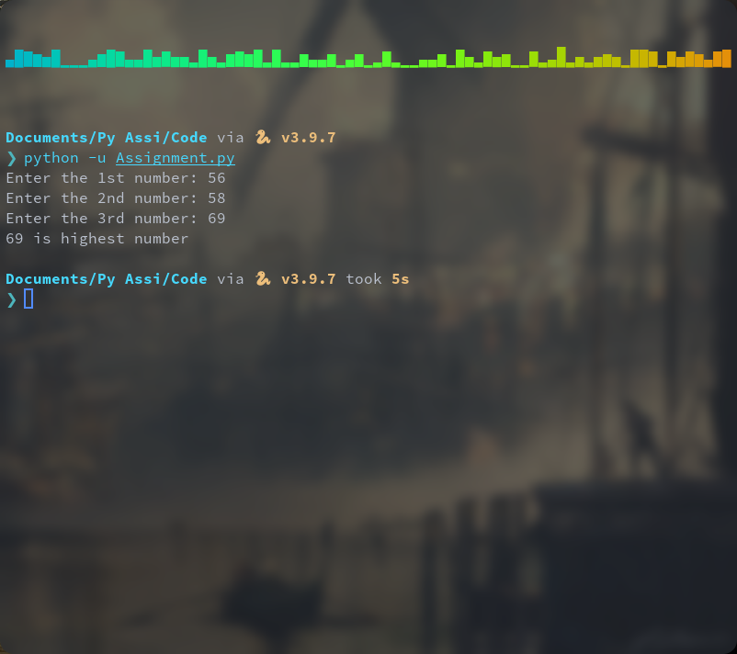

Problem statement:

Write a python program to check whether a year is Leap Year.

Assignment 3.b)

Source code:

a=int(input("enter a year:"))

if(a % 4) == 0:

if(a % 100) == 0:

if(a % 400) == 0:

print(a, " is a leap year")

else:

print(a , "is not a leap year")

else:

print(a ," is a leap year")

else:

print(a, " is not a leap year")

output:

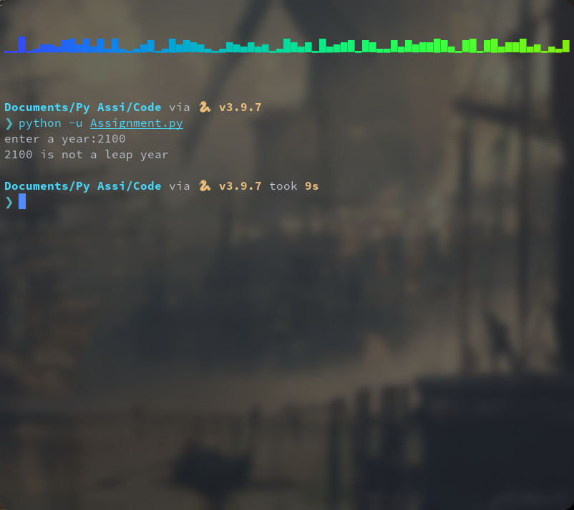

Problem statement:

In general, an equation of the form + + = 0 is known as quadratic equation. Accept the values of a, b, and c from the user and write a python program to calculate the roots of the given quadratic equation.

Assignment 3.c)

Source code:

a=eval(input("Enter the 1st number: "))

b=eval(input("Enter the 2nd number: "))

c=eval(input("Enter the 3rd number: "))

d=b*b - 4*a*c

if a==0:

print("It is not a quadratic equation")

elif d> 0:

r1 = ((-b)+d**0.5)/(2*a)

r2 = ((-b)-d**0.5)/(2*a)

print("the roots are {0:0.2} and {1:0.2}".format(r1,r2))

elif d==0:

r1 = (-b)/(2*a)

print("both roots are same and the roots is {}".format(r1))

else:

d=-1*d

i1=(d**0.5)/(2*a)

t1= (-b)/(2*a)

r1=complex(i1,t1)

r2=r1.conjugate()

print("the roots are {} and {}".format(r1,r2))

output:

